Title | Feature Engineering and Correlation Analysis Using Pandas
Problem Statement | Create a DataFrame with columns Feature1, Feature2, and Target containing predefined sample data stored in a Python dictionary. Create a new feature that is the logarithm of Feature1, bin Feature2 into three categories (Low, Medium, and High), and calculate the correlation matrix of the DataFrame. Finally, create a scatter plot of Feature1 versus Feature2 distinguished by Target and interpret the visible patterns.
Objectives | • To create a Pandas DataFrame using a predefined Python dictionary.  • To understand feature engineering using logarithmic transformation.  • To transform Feature1 using the natural logarithm function.  • To divide Feature2 into Low, Medium, and High categories.  • To calculate and interpret correlations among numerical variables.  • To visualize the relationship between Feature1 and Feature2 using a scatter plot.  • To distinguish Target classes using a black-and-white plotting format.  • To interpret visible trends, class overlap, and feature relationships.
Dataset  URL Link /  File | Predefined dictionary dataset used directly inside the Python program:  Record Feature1 Feature2 Target  1 5 10 0  2 8 18 0  3 12 15 1  4 15 25 0  5 18 30 1  6 22 28 1  7 25 35 0  8 30 40 1  9 35 38 1  10 40 45 0  11 45 50 1  12 50 55 1  13 55 60 0  14 60 65 1  15 70 75 1  No external CSV file, URL, database, or online dataset is required.
Functions  Details | Sl. No. | Function | Package | Description of function
 | 1 | pd.DataFrame() | Pandas | Creates a DataFrame from the predefined dictionary data.
 | 2 | np.log() | NumPy | Calculates the natural logarithm of each Feature1 value.
 | 3 | pd.cut() | Pandas | Bins Feature2 into Low, Medium, and High categories.
 | 4 | corr() | Pandas | Calculates pairwise correlations between numerical columns.
 | 5 | value_counts() | Pandas | Counts the number of records in each Feature2 category.
 | 6 | sort_index() | Pandas | Displays category counts in their defined category order.
 | 7 | round() | Python/Pandas | Rounds logarithmic and correlation values for readable output.
 | 8 | plt.figure() | Matplotlib | Creates a plotting area with the specified dimensions.
 | 9 | plt.scatter() | Matplotlib | Creates the Feature1 versus Feature2 scatter plot.
 | 10 | plt.xlabel()/ylabel() | Matplotlib | Adds descriptive labels to the plot axes.
 | 11 | plt.legend() | Matplotlib | Identifies the symbols used for each Target class.
 | 12 | plt.show() | Matplotlib | Displays the completed scatter plot on the screen.
Steps/  Process/  Procedure/  Algorithm/  Flowchart/  Model | Step 1: Import Pandas, NumPy, and Matplotlib.  Step 2: Define Feature1, Feature2, and Target values inside a Python dictionary.  Step 3: Convert the dictionary into a DataFrame using pd.DataFrame().  Step 4: Display the original DataFrame and confirm the available columns.  Step 5: Create Log_Feature1 by applying np.log() to Feature1.  Step 6: Bin Feature2 into three equal-width categories using pd.cut().  Step 7: Label the categories as Low, Medium, and High.  Step 8: Select the numerical columns required for correlation analysis.  Step 9: Calculate and display the correlation matrix using corr().  Step 10: Count the number of observations in each Feature2 category.  Step 11: Create a black-and-white scatter plot of Feature1 versus Feature2 grouped by Target.  Step 12: Interpret the correlation, trend, and overlap visible in the output.
Program | import pandas as pd  import numpy as np  import matplotlib.pyplot as plt  # Predefined dictionary dataset  data = {  "Feature1": [5, 8, 12, 15, 18, 22, 25, 30,  35, 40, 45, 50, 55, 60, 70],  "Feature2": [10, 18, 15, 25, 30, 28, 35, 40,  38, 45, 50, 55, 60, 65, 75],  "Target": [0, 0, 1, 0, 1, 1, 0, 1,  1, 0, 1, 1, 0, 1, 1]  }  # Convert dictionary into a DataFrame  df = pd.DataFrame(data)  print("ORIGINAL DATAFRAME")  print(df)  print("DataFrame Shape:", df.shape)  # Create logarithmic feature  df["Log_Feature1"] = np.log(df["Feature1"])  print("\nDATAFRAME WITH LOG FEATURE")  print(df[["Feature1", "Log_Feature1"]].round(3))  # Bin Feature2 into three categories  df["Feature2_Category"] = pd.cut(  df["Feature2"],  bins=3,  labels=["Low", "Medium", "High"]  )  print("\nFEATURE2 CATEGORIES")  print(df[["Feature2", "Feature2_Category"]])  # Calculate correlation matrix  numeric_columns = [  "Feature1", "Feature2", "Target", "Log_Feature1"  ]  correlation_matrix = df[numeric_columns].corr()  print("\nCORRELATION MATRIX")  print(correlation_matrix.round(3))  # Display category-wise counts  category_count = (  df["Feature2_Category"]  .value_counts()  .sort_index()  )  print("\nFEATURE2 CATEGORY COUNT")  print(category_count)  # Create black-and-white scatter plot  class_zero = df["Target"] == 0  class_one = df["Target"] == 1  plt.figure(figsize=(8, 6))  plt.scatter(  df.loc[class_zero, "Feature1"],  df.loc[class_zero, "Feature2"],  facecolors="white",  edgecolors="black",  marker="o",  label="Target = 0"  )  plt.scatter(  df.loc[class_one, "Feature1"],  df.loc[class_one, "Feature2"],  color="black",  marker="s",  label="Target = 1"  )  plt.title("Feature1 vs. Feature2 Grouped by Target")  plt.xlabel("Feature1")  plt.ylabel("Feature2")  plt.grid(True, linestyle="--", alpha=0.5)  plt.legend()  plt.tight_layout()  plt.show()  # Interpret visible patterns  feature_correlation = df["Feature1"].corr(df["Feature2"])  print("\nPATTERN INTERPRETATION")  print(  "Correlation between Feature1 and Feature2:",  round(feature_correlation, 3)  )  print(  "Feature1 and Feature2 have a strong positive "  "relationship. Target classes overlap, although "  "Target = 1 appears more often at medium and high values."  )

Output Snapshots  With  Explanation/  Observations | Screenshot 1: Original DataFrame  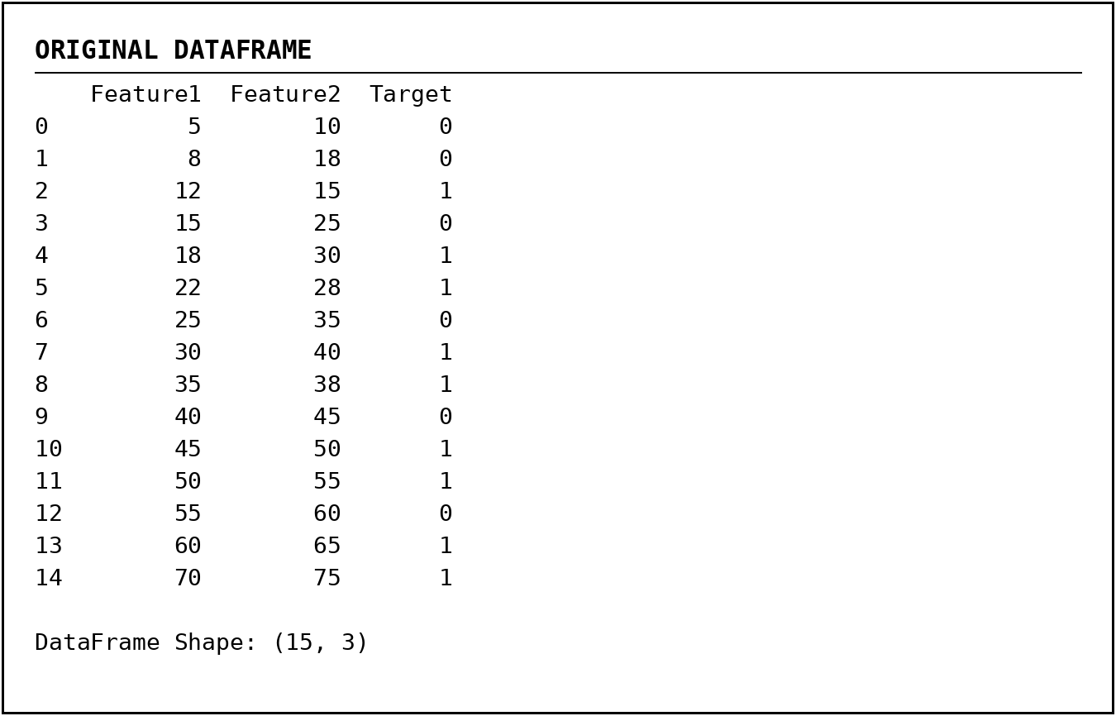  Figure 1.1 - Original DataFrame  Explanation/Observation: The dictionary was converted into a DataFrame containing 15 observations and the three required columns: Feature1, Feature2, and Target.  Screenshot 2: Logarithmic Feature  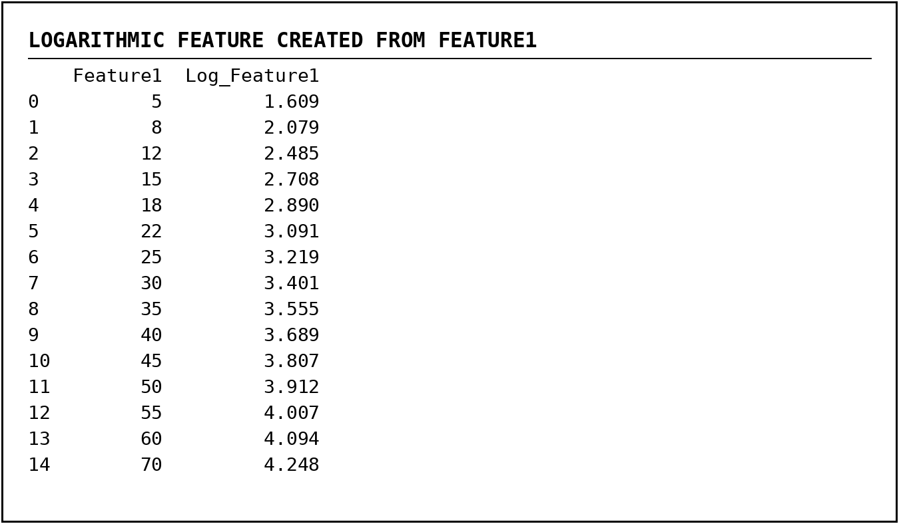  Figure 1.2 - Logarithmic Transformation of Feature1  Explanation/Observation: The natural logarithm of Feature1 was calculated using np.log(). The transformed values increase gradually and reduce the scale difference among larger values.  Screenshot 3: Feature2 Binning  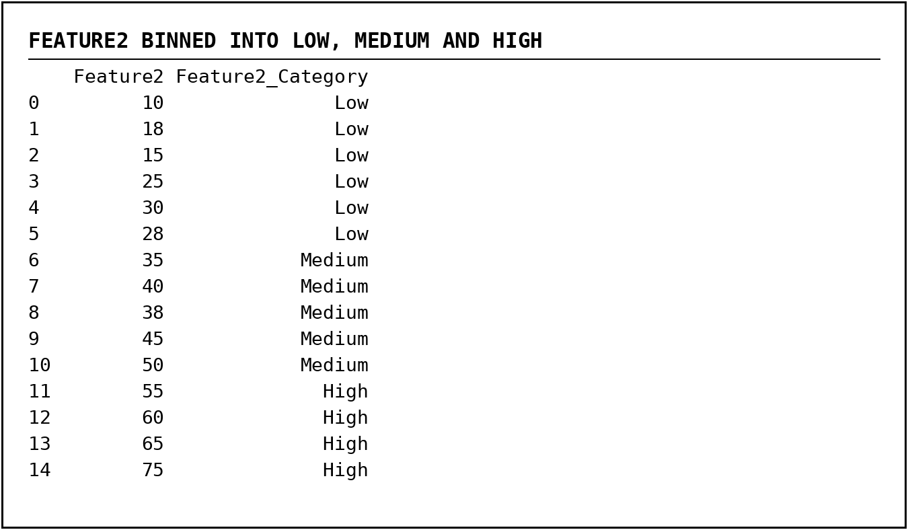  Figure 1.3 - Feature2 Categorized as Low, Medium, and High  Explanation/Observation: The pd.cut() function divided Feature2 into three equal-width categories. The output contains 6 Low, 5 Medium, and 4 High observations.  Screenshot 4: Correlation Matrix  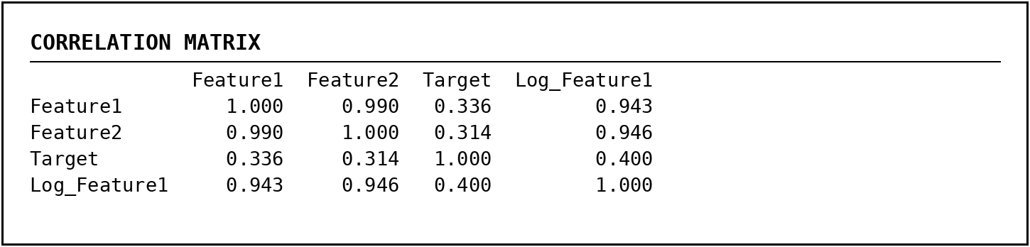  Figure 1.4 - Correlation Matrix of Numerical Features  Explanation/Observation: Feature1 and Feature2 have a very strong positive correlation of approximately 0.990. Log_Feature1 also has strong positive relationships with both original features.  Screenshot 5: Category Count and Pattern Interpretation  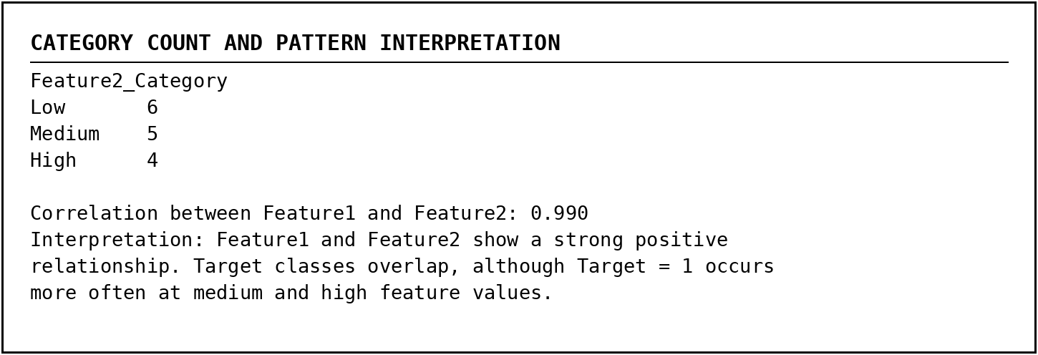  Figure 1.5 - Category Counts and Console Interpretation  Explanation/Observation: The category distribution and calculated correlation confirm an increasing relationship between Feature1 and Feature2. Target classes overlap, so the features do not completely separate the two classes.  Screenshot 6: Scatter Plot  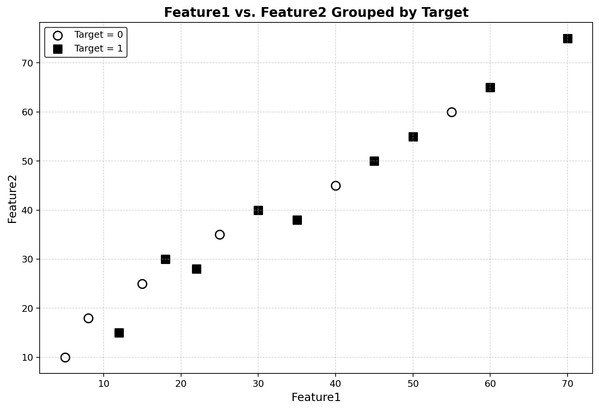  Figure 1.6 - Feature1 versus Feature2 Grouped by Target  Explanation/Observation: The points follow a clear upward pattern, showing that Feature2 generally increases as Feature1 increases. Black squares represent Target = 1, while white circles represent Target = 0. The classes overlap, but Target = 1 occurs more frequently at medium and high feature values.
Conclusions | The feature engineering and correlation analysis exercise was completed successfully using Pandas, NumPy, and Matplotlib. A DataFrame was created from a locally defined Python dictionary. A logarithmic feature was generated from Feature1, Feature2 was categorized into Low, Medium, and High groups, and a correlation matrix was calculated for the numerical variables. The correlation value of approximately 0.990 showed a very strong positive relationship between Feature1 and Feature2. The black-and-white scatter plot confirmed the upward trend and showed that the Target classes overlap, although Target = 1 appears more frequently at medium and high feature values. The exercise provided practical understanding of feature transformation, binning, correlation analysis, visualization, and pattern interpretation.
References | 1. Pandas documentation for DataFrame creation, binning, category counting, and correlation analysis.  2. NumPy documentation for logarithmic transformations.  3. Matplotlib documentation for scatter plots, legends, labels, and plot formatting.  4. Programming for Data Science (MACSE502) class lecture notes (https://drive.google.com/file/d/1PqsD1tC9aCgGFZo7QIJblBu1pIjg4UBs/view)

